TRINITY PRIMARY SCHOOL-BUKOTO
For examiner’s use only
A
B
TOTAL
REVISION WORK
CLASS: P.4
SUBJECT: SCIENCE
TIME ALLOWED: 2HOURS 15 MINUTES

Name __________________________________________Stream __________
SECTION A: (40MARKS)
- Name the garden tool used for digging.
___________________________________________________________
- Which animal is kept at home for security?
___________________________________________________________
- Why do we brush our teeth?
______________________________________________________________
- Name one element of a good map.
________________________________________________________________
- Why is it dangerous to disturb bees?
________________________________________________________________
- How is the garden tool below useful to people?

_______________________________________________________________
- State one cultural practice in a community.
________________________________________________________________
- Give one danger of child abuse.
________________________________________________________________
- How are forests important to carpenters?
________________________________________________________________
- Name the place where people keep their money safe.
________________________________________________________________
- Name any one type of transport.
________________________________________________________________
- Identify the fruit below.
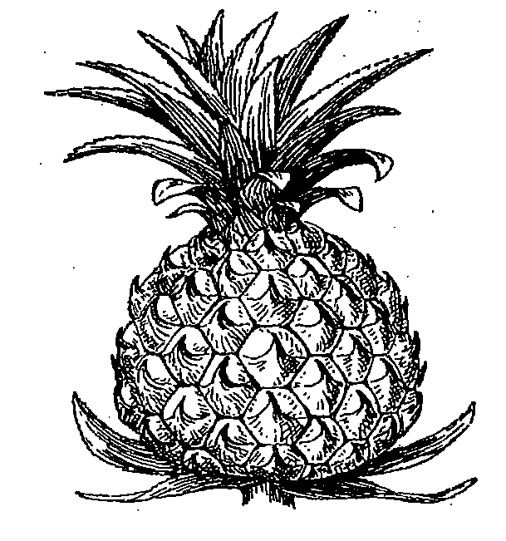____________________________________________
- Give one example of a cardinal point of a compass?
_______________________________________________________________
- Who heads a parish?
______________________________________________________________
- Why do animals move from one place to another?
________________________________________________________________
- Apart from a School, name any other important place in the community?
_______________________________________________________________
- Mention one danger of accidents to people.
_______________________________________________________________
- Name the clouds that give us rain.
________________________________________________________________
- Give one use of a bed in the house?
________________________________________________________________
- Why should a classroom have a dustbin?
________________________________________________________________
- Write one use of food to the body
________________________________________________________________
- Why do we have chairs in the classroom?
________________________________________________________________
- Draw the human body part used for seeing.

- Name one habitat of fish.
________________________________________________________________
- Give one use of pots to people.
________________________________________________________________
- In which type of family do we find uncle?
________________________________________________________________
- Why do people keep hens at home?
________________________________________________________________
- Write any one way soil is formed.
_______________________________________________________________
- Name the importance place in the community where people go to buy items.
________________________________________________________________
- Why should water for drinking be boiled?
________________________________________________________________
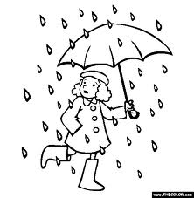
- Identify the type of weather shown in the diagram below.

_____________________________________

- How is a housefly dangerous to people?
________________________________________________________________
- How is a police man useful to the community?
________________________________________________________________
- Give one way people can care for their hair.
______________________________________________________________
- Name any one item we can use to make ropes.
_______________________________________________________________
- Give any one way farming is important to people.
______________________________________________________________
- What does the symbol below represent?
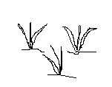________________________________________________
- What do we call a young cow?
______________________________________________________________
- Name part of the insect marked x
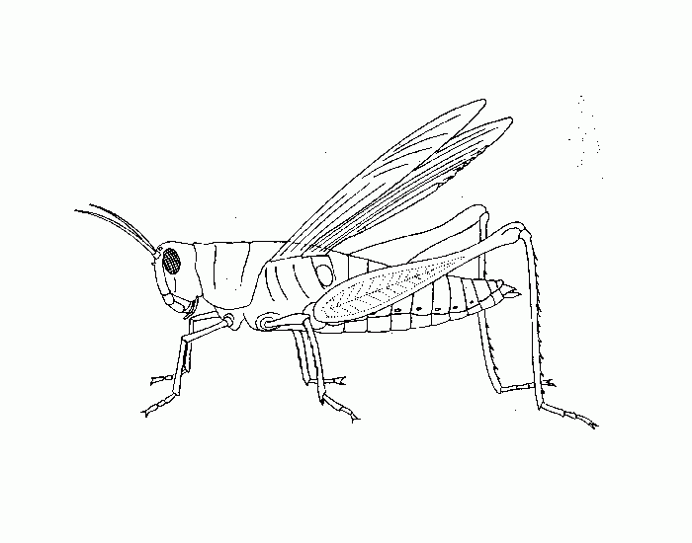
x

____________________________________________________________
- State any one importance of a balanced diet.
________________________________________________________________

SECTION B: (60 MARKS)
- (a) What is transport
________________________________________________________________________________________________________________________________
(b) Apart from road transport, write any other two types of transport. (i)_________________________(ii) _________________________________
(c) Name any one means of road transport.
_______________________________________________________________
- (a) Name the three main body parts of an insect
- _________________ (ii) __________________(iii) ________________
(b) On which main body part of an insect are the wings found? ________________________________________________
- (a) Name two crops grown in swamps.
- ______________________________________________________
(ii) ______________________________________________________
(b)Why is it not good to settle in swamps?
_____________________________________________________________
- Mention one building material got from swamps.
_____________________________________________________________
- (a) What is a nuclear family?
________________________________________________________________________________________________________________________________
(b) List any two members of a nuclear family.
(i) ____________________________________________________________
(ii) ____________________________________________________________
(c)Apart from the nuclear family, name any other type of family.
____________________________________________________________

- (a) Write any two agents of soil erosion.
(i) ___________________________________________________
(ii) ____________________________________________________
b) How do famers control soil erosion in the garden?
__________________________________________________________
c) Name one activity that causes soil erosion.
____________________________________________________________
- (a) How can wind be useful to people?
____________________________________________________________
(b) Write any two dangers of strong wind.
(i) _________________________________________________________
(ii) _________________________________________________________
(c) How can we protect the environment?
___________________________________________________________
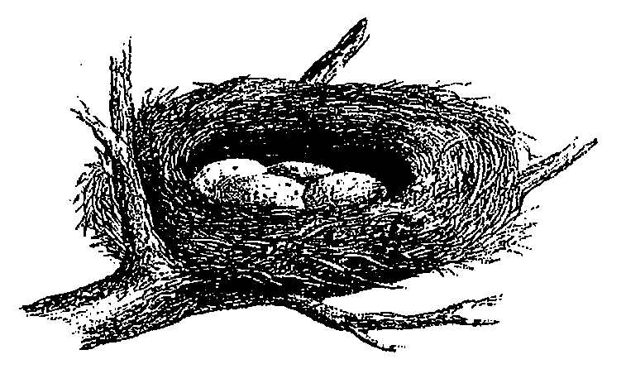
- Below is a diagram of an animal habitat. Use it to answer questions that follow.

(a) Identify the above animal home.
_____________________________________________________________
(b) Name the animal that lives in the above habitat.
_____________________________________________________________
(c) Write two materials used to make the above habitat.
(i)________________________ (ii) ____________________________
- (a) Give any one use of a house at home.
_____________________________________________________________
(b) Name any two materials we use when building a house.
(i) ______________________________________________
(ii) ______________________________________________
(c) Mention any one thing found in a sitting room.
___________________________________________________________
- Match the animals to their young ones.
Animal Young one
i) Cat Calf
ii) Dog Kitten
iii) Cow kid
iv) Goat Puppy
- (a) Write the main source of water in the environment.
___________________________________________________________
(b) State any two ways water can get dirty.
(i) _______________________________________________________
(ii) _______________________________________________________
(c) Give one use of water at home.
____________________________________________________________
- (a) Name any two insects that can be eaten.
i) ___________________________________________________
ii) ___________________________________________________
- Mention one insect without wings.
__________________________________________________________
- How many legs does an insect have?
___________________________________________________________
- (a) Write any one way people care for their beddings.
_____________________________________________________________
(b) Give two activities we do to keep our bodies clean.
i) ______________________________________________________
ii) ______________________________________________________
(c) Name one material we use to keep our bodies clean.
_______________________________________________________

- The diagram below is of a tool used in giving first aid. Use it to answer question 54.

- Name the equipment.
_____________________________________________________________
(b) Identify two tools kept in the equipment above?
(i) _________________________________________________________
(ii) _________________________________________________________
c) Give one accident that may cause bleeding.
________________________________________________________________
- (a) Name any two elements of weather.
(i) __________________________________________________________
(ii) __________________________________________________________
(b) Give any two types of weather.
(i) __________________________________________________________
(ii) __________________________________________________________
- (a) What is a map?
__________________________________________________________________________________________________________________________
(b) How are maps important to people?
________________________________________________________________________________________________________________________________
(c) Draw a map of the following;

tree | table

End

